BigCommerce

1. Log in in BigCommerce with your account information:

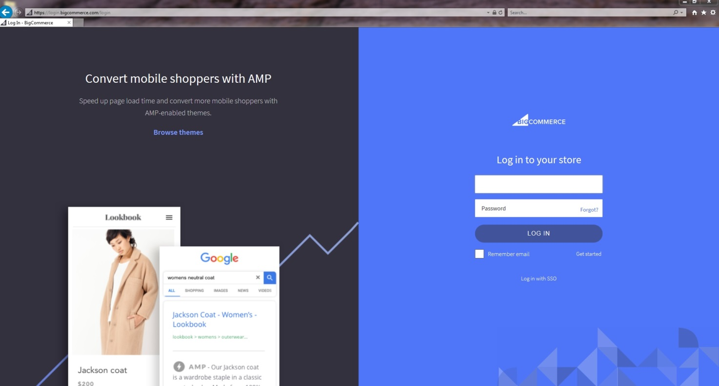

1. Go in a section menu: Advanced Settings.

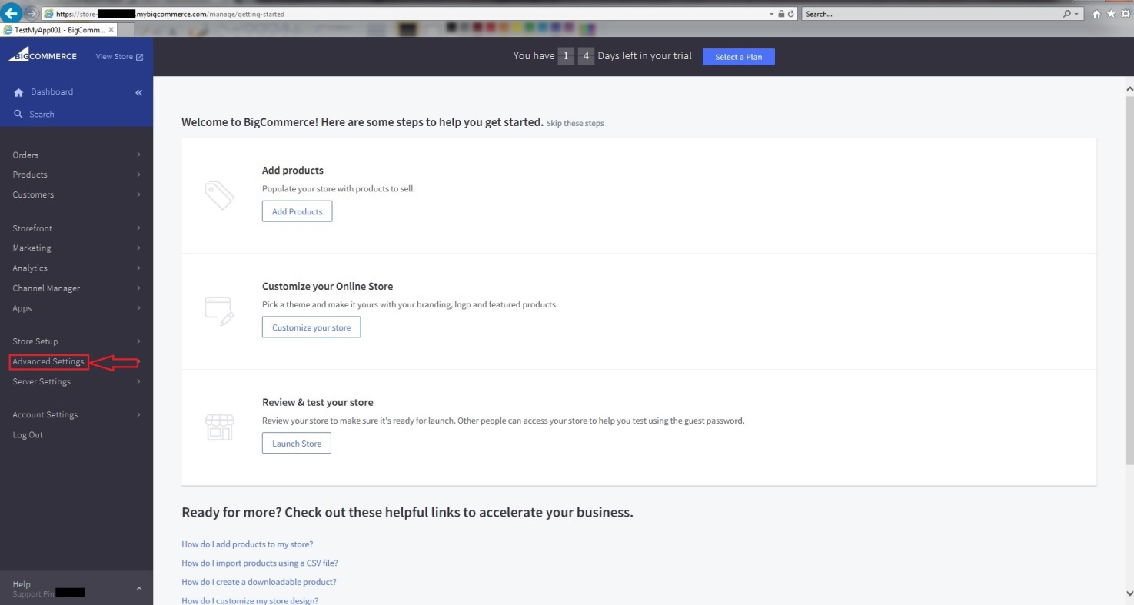

1. Go to menu API Account.

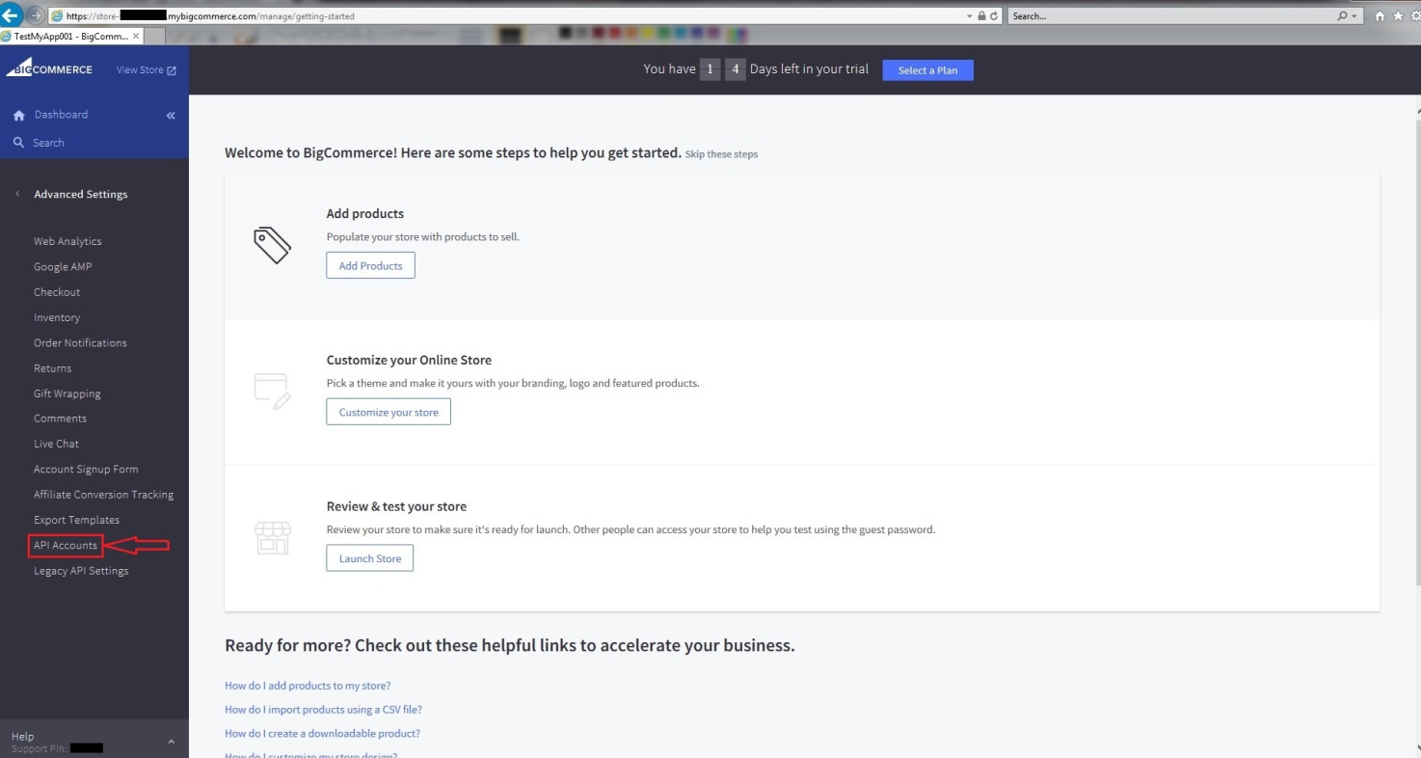

1. Create API Account.

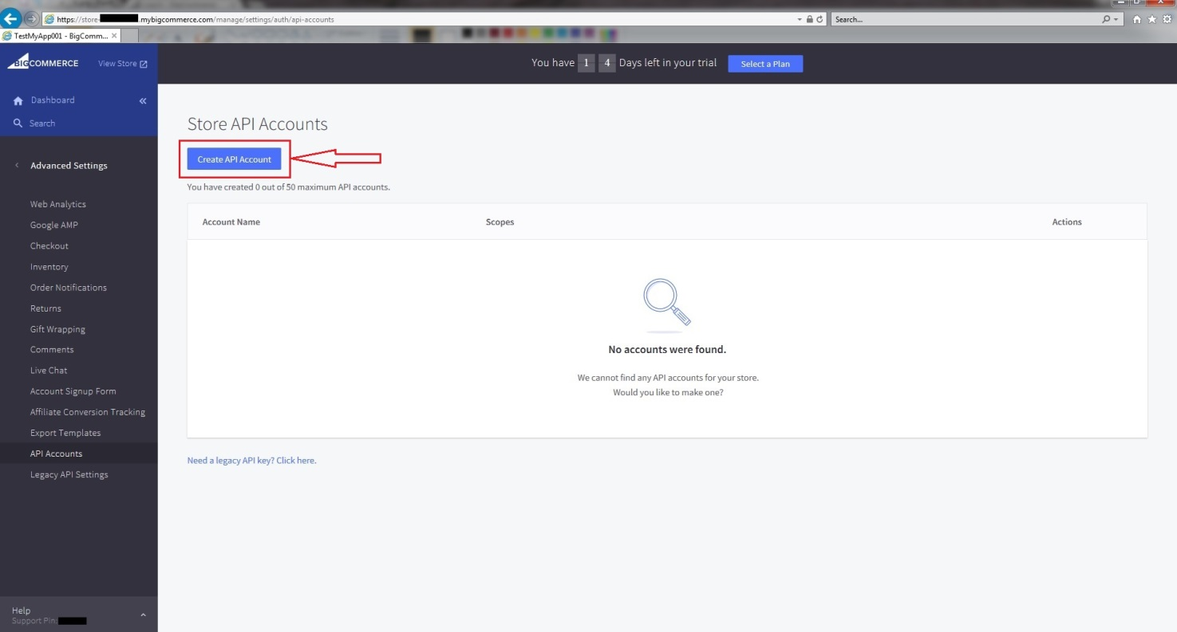

1. Enter: Name and modify(if need) Scopes. Save store_hash and push Save.

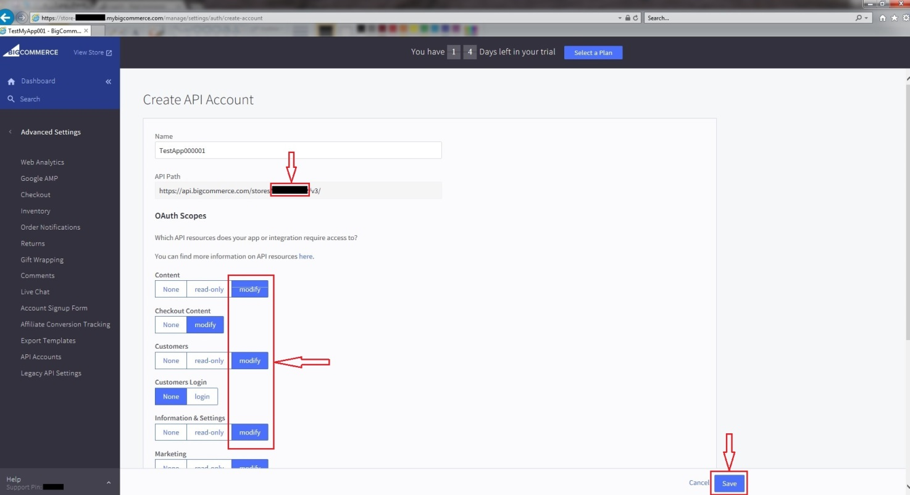

1. And show BigCommerce API Credentials.

Important: This is the only copy you will have access to. If you lose it, delete the account and create a new one!!!!

